实验 软件架构

实验者：单楚雄 实验日期：2024/4/10 实验地点：信息楼215
一、实验目的
1熟悉前后端分离下的软件架构。
2实现前后端通信
3实现后端与数据库通信
4完成前后端分离实验《Todos》

二、实验装置
IDE: VS Code
后端（Java）: jdk8，jre8
后端（node）：node，Npm
数据库：MySQL，navicat
前端：Yarn

三、实验内容
1. MVC架构
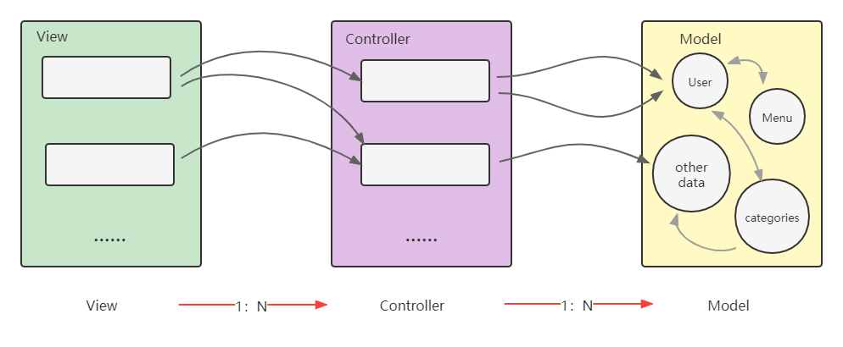

2. 系统流程
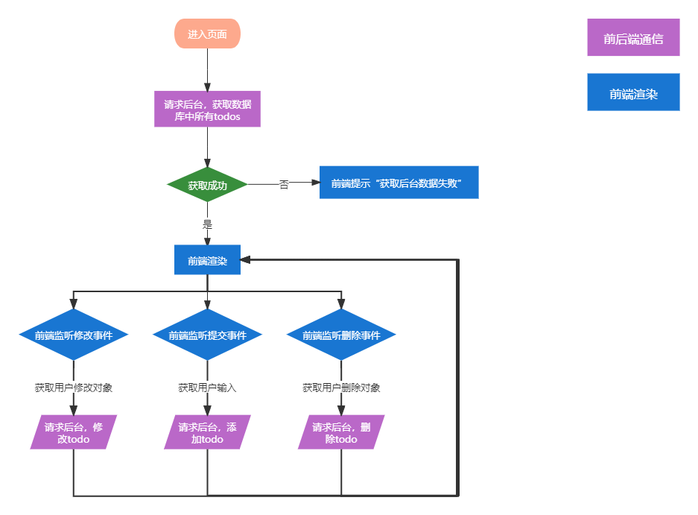

3. 后端连接数据库
3.1配置文件
进入be-spring/src/main/resources，创建application.properties
spring.jpa.hibernate.ddl-auto=update
spring.datasource.url=jdbc:mysql://${MYSQL_HOST:localhost}:3306/todos
spring.datasource.username=root
spring.datasource.password=root
spring.datasource.driver-class-name =com.mysql.jdbc.Driver

3.2 定义数据访问层Data Access Object
package com.example.accessingdatamysql;

import org.springframework.boot.SpringApplication;
import org.springframework.boot.autoconfigure.SpringBootApplication;

@SpringBootApplication
public class AccessingDataMysqlApplication {
public static void main(String[] args) {
SpringApplication.run(AccessingDataMysqlApplication.class, args);
}
}
3.3定义数据模型Model
进入be-spring/src/main/java/com/example/accessingdatamysql/model，创建TodoList.java
4. 后端操作数据库
4.1查询数据库中所有todos
public @ResponseBody Iterable<TodoList> getAllTodos() {
// This returns a JSON or XML with the todos
return todoListRepository.findAll();
}
4.2往数据库里增加一条todo
public @ResponseBody String addNewTodo (@RequestBody String todo) {
Map<String, Object> todoObj = JSON.parseObject(todo, Map.class);
Map<String, Object> todoMap = JSON.parseObject(todoObj.get("data").toString(), Map.class);
TodoList newTodo = new TodoList();
newTodo.setId(todoMap.get("id").toString());
newTodo.setText(todoMap.get("text").toString());
newTodo.setFinished(0);
todoListRepository.save(newTodo);
return "Saved";
}
4.3修改数据库中todo的finish状态
public @ResponseBody String fininshTodo (@RequestBody String todo) {
Map<String, Object> todoObj = JSON.parseObject(todo, Map.class);
Map<String, Object> todoMap = JSON.parseObject(todoObj.get("data").toString(), Map.class);
TodoList newTodo = todoListRepository.findById(todoMap.get("id").toString()).get();
newTodo.setFinished("true".equals(todoMap.get("finished").toString()) ? 1 : 0);
todoListRepository.save(newTodo);
return "Saved";
}
4.4根据id删除数据库中的一条todo
public @ResponseBody String deleteTodo (@RequestBody String todo) {
Map<String, Object> todoObj = JSON.parseObject(todo, Map.class);
Map<String, Object> todoMap = JSON.parseObject(todoObj.get("data").toString(), Map.class);
todoListRepository.deleteById(todoMap.get("id").toString());
return todoMap.get("id").toString();
}
4.5 修改为rest风格
@RequestMapping(path="/api")
@GetMapping(path="/getTodos")
@PostMapping(path="/addTodo", produces="application/json;charset=UTF-8")
@PostMapping(path="/finishTodo", produces="application/json;charset=UTF-8")
@PostMapping(path="/delTodo", produces="application/json;charset=UTF-8")
4.6 完整的Controller
package com.example.accessingdatamysql;

import org.springframework.beans.factory.annotation.Autowired;
import org.springframework.stereotype.Controller;
import org.springframework.web.bind.annotation.GetMapping;
import org.springframework.web.bind.annotation.PostMapping;
import org.springframework.web.bind.annotation.DeleteMapping;
import org.springframework.web.bind.annotation.RequestMapping;
import org.springframework.web.bind.annotation.RequestParam;
import org.springframework.web.bind.annotation.ResponseBody;
import org.springframework.web.bind.annotation.RequestBody;
import com.alibaba.fastjson.JSON;
import java.util.Map;

@Controller // This means that this class is a Controller
@RequestMapping(path="/api") // This means URL's start with /api (after Application path)
public class MainController {
@Autowired // This means to get the bean called todoListRepository Which is auto-generated by Spring, we will use it to handle the data
private TodoListRepository todoListRepository;

@GetMapping(path="/getTodos")
public @ResponseBody Iterable<TodoList> getAllTodos() {
// This returns a JSON or XML with the todos
return todoListRepository.findAll();
}

@PostMapping(path="/addTodo", produces="application/json;charset=UTF-8") // Map ONLY POST Requests
public @ResponseBody String addNewTodo (@RequestBody String todo) {
Map<String, Object> todoObj = JSON.parseObject(todo, Map.class);
Map<String, Object> todoMap = JSON.parseObject(todoObj.get("data").toString(), Map.class);
TodoList newTodo = new TodoList();
newTodo.setId(todoMap.get("id").toString());
newTodo.setText(todoMap.get("text").toString());
newTodo.setFinished(0);
todoListRepository.save(newTodo);
return "Saved";
}

@PostMapping(path="/finishTodo", produces="application/json;charset=UTF-8")
public @ResponseBody String fininshTodo (@RequestBody String todo) {
Map<String, Object> todoObj = JSON.parseObject(todo, Map.class);
Map<String, Object> todoMap = JSON.parseObject(todoObj.get("data").toString(), Map.class);
TodoList newTodo = todoListRepository.findById(todoMap.get("id").toString()).get();
newTodo.setFinished("true".equals(todoMap.get("finished").toString()) ? 1 : 0);
todoListRepository.save(newTodo);
return "Saved";
}

@PostMapping(path="/delTodo", produces="application/json;charset=UTF-8")
public @ResponseBody String deleteTodo (@RequestBody String todo) {
Map<String, Object> todoObj = JSON.parseObject(todo, Map.class);
Map<String, Object> todoMap = JSON.parseObject(todoObj.get("data").toString(), Map.class);
todoListRepository.deleteById(todoMap.get("id").toString());
return todoMap.get("id").toString();
}
}

5 前端与后端通信
5.1 发起添加一条todo的请求
// post to backend
axios.post(`/${useApi}/addTodo`, {
headers: {'Content-Type': 'application/json'},
data: JSON.stringify(todoObj)
}).then((res) => {

// request from backend
if (res.status === 200) {
// update localStorage & page
setLocalTodos(
[
...localTodos,
todoObj
]
)
} else {
throw new Error(res)
}
}).catch((err) => {
throw new Error(err)
})

5.2 发起修改一条todo的finish状态的请求
// post to backend
axios.post(`/${useApi}/finishTodo`, {
headers: {'Content-Type': 'application/json'},
data: JSON.stringify(todoObj)
}).then((res) => {

// request from backend
if (res.status === 200) {
// update localStorage & page
setLocalTodos(localTodos.map(localItem => {
if (localItem.id === todoItem.id) localItem.finished = !localItem.finished
return localItem
}))
} else {
throw new Error(res)
}
}).catch((err) => {
throw new Error(err)
})

5.3 发起删除一条todo的请求
axios.post(`/${useApi}/delTodo`, {
headers: {'Content-Type': 'application/json'},
data: JSON.stringify(todoObj)
}).then((res) => {

// request from backend
if (res.status === 200) {
// update localStorage & page
setLocalTodos(localTodos.filter(item => item.id !== id))
} else {
throw new Error(res)
}
}).catch((err) => {
throw new Error(err)
})
运行后前端界面如下:
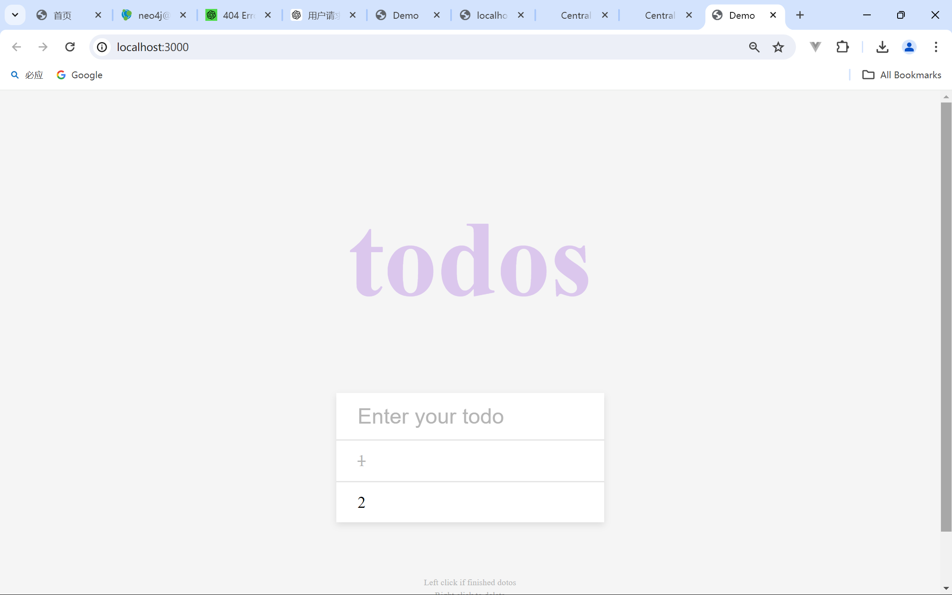
数据库更新:
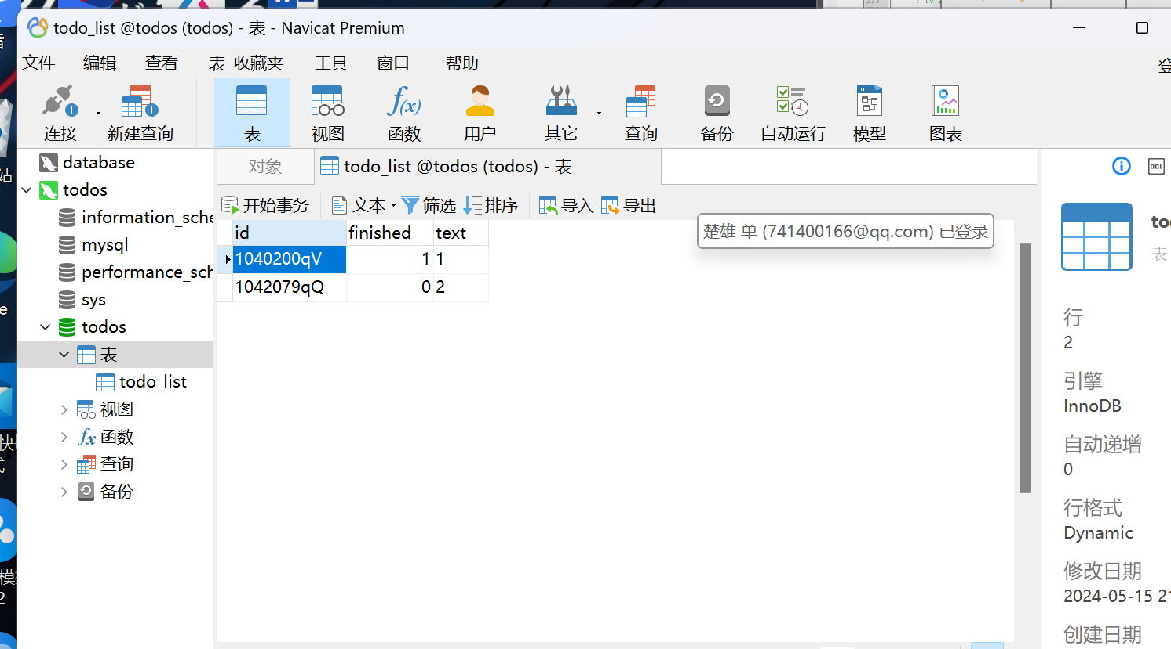

网络请求正常
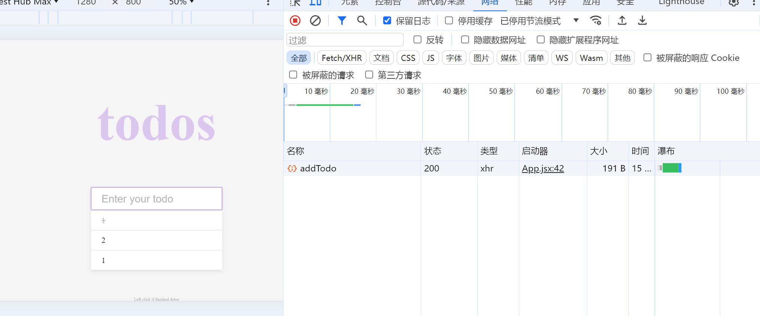

实验成绩：____________ 教师签名：_______________

